Quarterly Report – Public Page

Date of Report: 7th Quarterly Report, June 30, 2025
Contract Number: 693JK32310013POTA
Prepared for: Government Agency: DOT and Co-funders
Project Title: Tank Foundation and Floor Designs and Best Practices for Improved Corrosion Control
Prepared by: Pipeline Research Council International (PRCI), Inc.
Contact Information: Janie Norton, jnorton@prci.org 703-205-1600 ext: 105
For quarterly period ending: June 30, 2025

1: Items Completed During this Quarterly Period:

Item # | Task # | Activity/Deliverable | Title | Federal Cost | Cost Share
7 | 4 | Developing Guidance on Best Practices for Sealing Tank Bottoms to Prevent Water and Foreign Material in Single and Multi-bottom Tanks. | Summary Report of Findings on Best Practices For Sealing Tanks to be included in the quarterly report. | $36,276 | $9,069
14 | 5 | 7th quarterly status report & project management | Submit 7th Quarterly Status Report | $11,618 | $2,905

2: Items Not-Completed During this Quarterly Period:

Item # | Task # | Activity/Deliverable | Title | Federal Cost | Cost Share
11 | 5 | Research on Improved Corrosion Control and CP Methodologies for New and Existing Tanks and Tanks Single and Double bottom Tanks. | Draft Summary on Corrosion Control CP methodologies for new and retrofit Construction Results to be included in the quarterly report. | $25,356 | $6,339
13 | 5 | Research on Corrosion Control and CP Monitoring for New and Existing Tanks with Single and Double Bottom Tanks | Draft Summary on Improved Corrosion Control Monitoring Results to be included in the quarterly report | $25,356 | $6,339

3: Project Financial Tracking During this Quarterly Period:

Note that this chart reflects Federal share only:

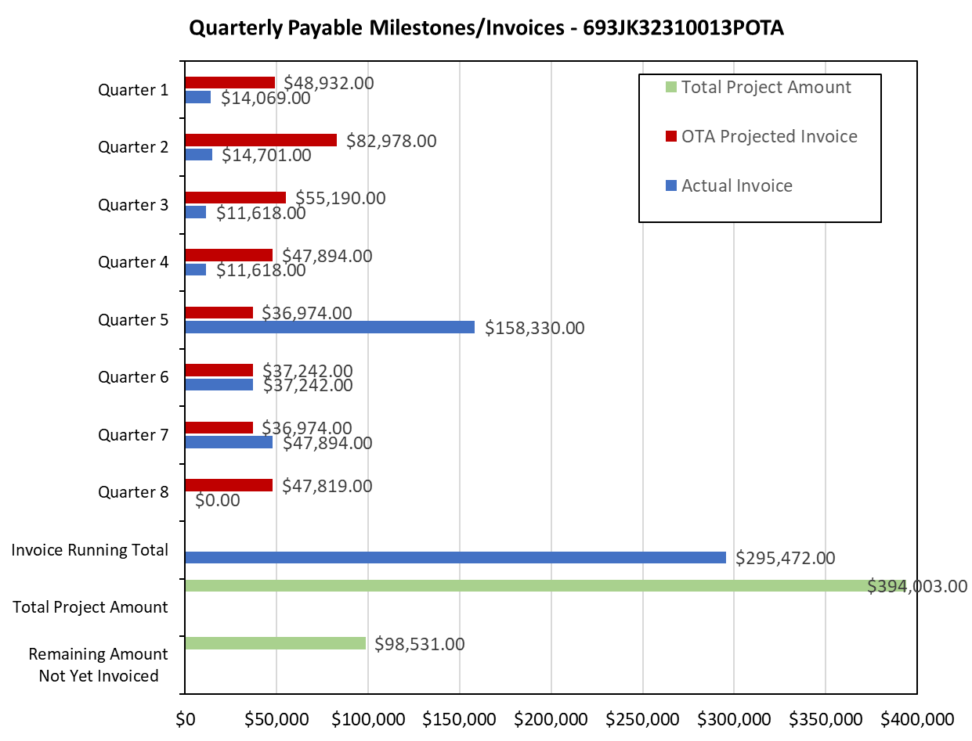

4: Project Technical Status –

Task 5- Completed draft report on Research on Best Practice for Corrosion Control for New and Existing Tanks and Tanks on Solid Pads. Under internal Mears team review.

5: Project Schedule –

The project schedule issues resolved. On Schedule

